Policy# 1827484 (copied from production and force renewed)

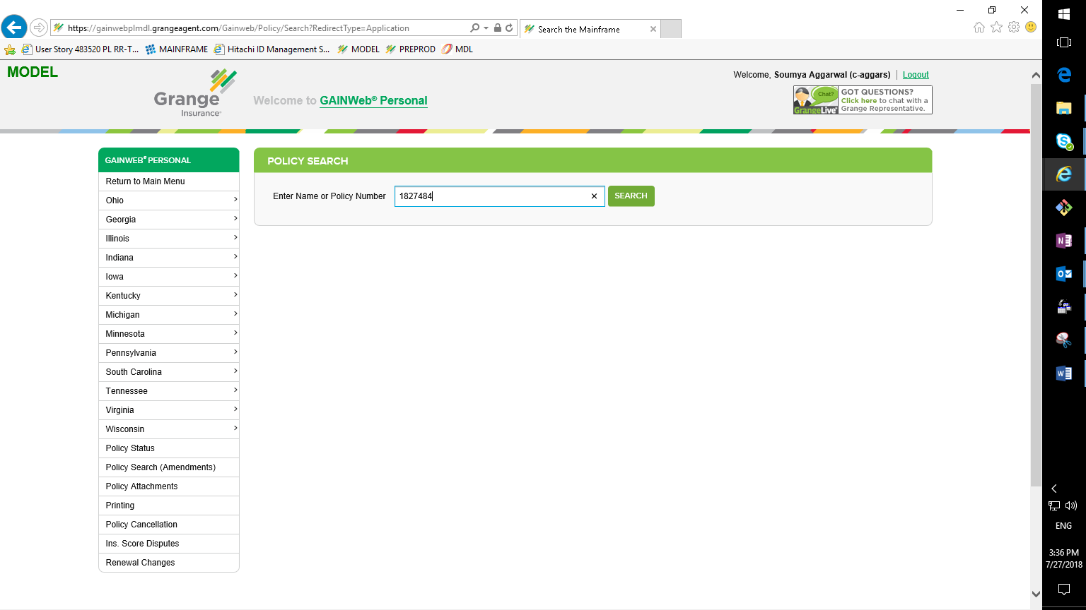

Select the mod which has eff date >= 10/15/2018

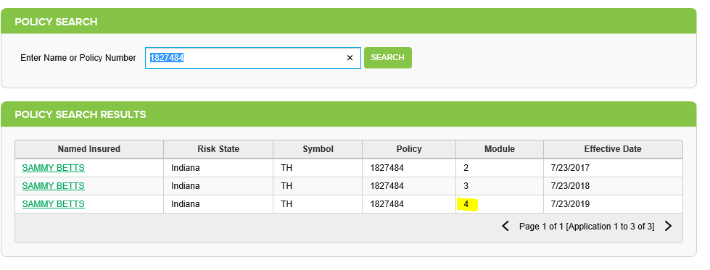

Get Quote

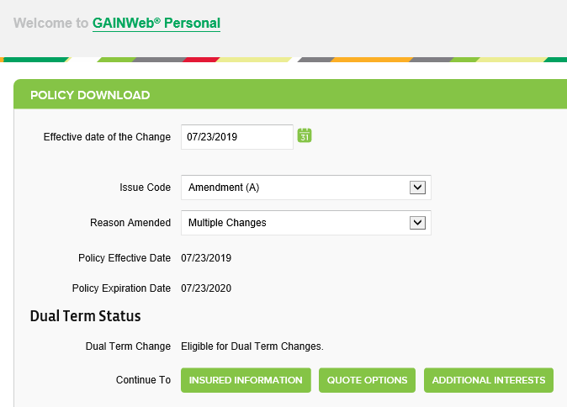

Get the Policy ID from the URL as highlighted

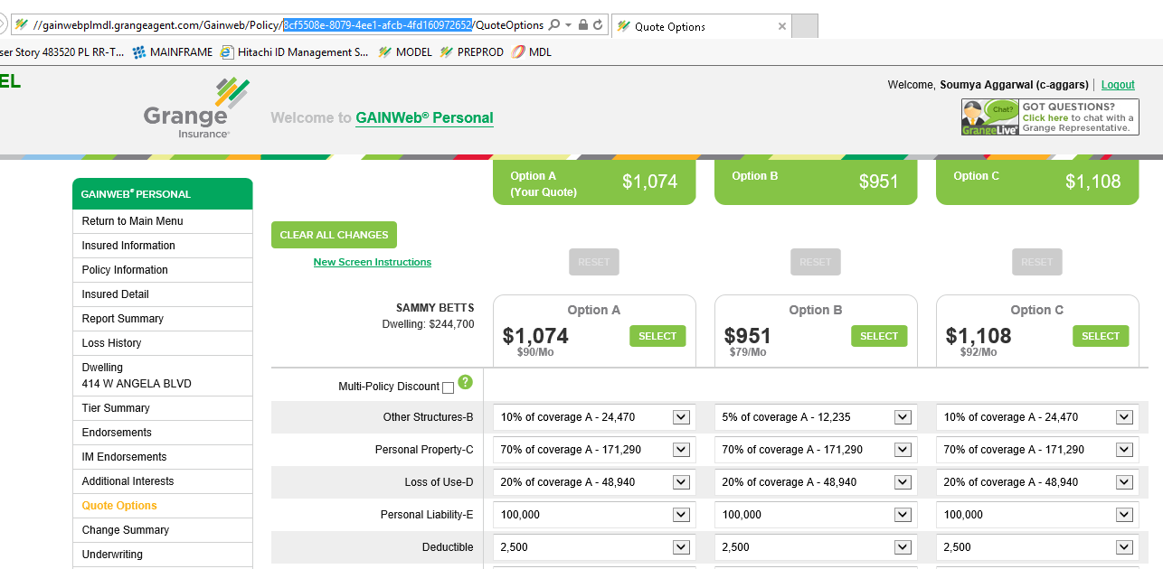

Open rate log viewer and click “here” hyperlink

(Or else for general auto policies, enter the policy ID from above step. Get Quotes)

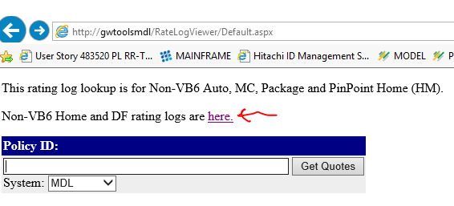

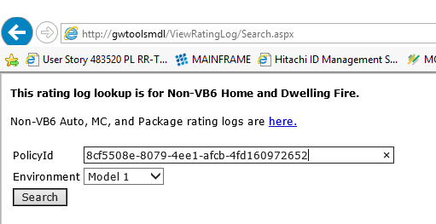

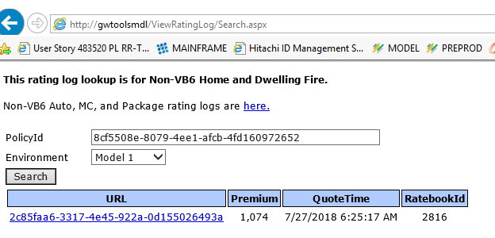

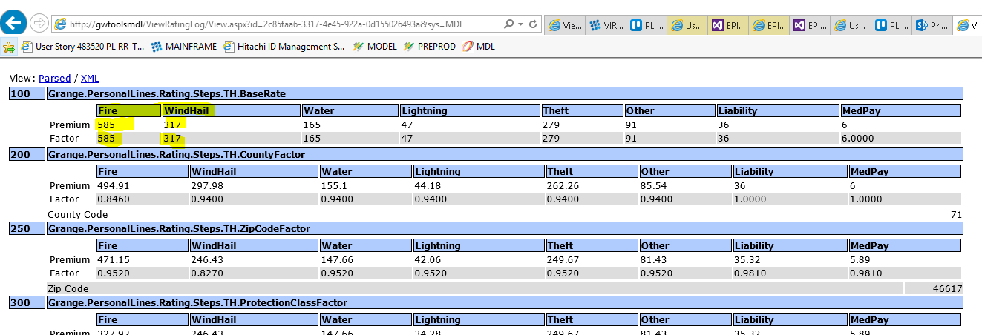

Compare with the pricing spreadsheet of IN TH available at sharepoint

